**ONLINE BANKING WEBSITE**

END TERM REPORT

*by*

ANURAG KUAMR

NEERAJ KUMAR  
VISHAL KUMAR

(Section: K19JP)

(Roll Numbers:06, 12, 27)



**Department of Intelligent Systems**

**School of Computer Science Engineering**

**Lovely Professional University, Jalandhar**

**April - 2020**

**Student Declaration**

This is to declare that this report has been written by us. No part of the

report is copied from other sources. All information included from other sources have been duly acknowledged. We aver that if any part of the report is found to be copied, we are shall take full responsibility for it.

Signature of Student:

*anurag kumar*

Name of Student:

ANURAG KUMAR

Roll Number: 06

Signature of Student:

*niraj kumar*

Name of Student:

NEERAJ KUMAR

Roll Number: 12

Signature of Student:

*vishal kumar*

Name of Student:

VISHAL KUMAR

Roll Number: 27

Place: Lovely Professional University

Date: 09/04/2020

**SYNOPSIS**

**INTRODUCTION**

HTML stands for Hypertext and Markup Language. Hypertext defines the link between the web pages. Markup Language is used to define the text document within a tag which defines the structure of web pages.

**BACKGROUND AND OBJECTIVES**

* Cashless
* Funds Transfer
* Monitoring the customer feedback.
* Mini statement, Monthly statement
* E- Passbook

**DESCRIPTION**

In the online banking system project users can create free account and can keep their data online and easy to use.

**MODULE**

* Login Process
* Balance Enquiry
* Update Profile
* Funds Transfer
* Change of Password
* Mini Statements

**TECHNOLOGIES TO BE USED**

* HTML
* CSS

**SWOT ANALYSIS**

**TABLE OF CONTENTS**

**TITLE PAGE NO.**

1. **Background and objectives of project assigned**

**1**

**1.1 Background**

**1.1.1** As our project is online banking site, we collected

Images from different sites from the internet.

**1.1.2** In background we tried to show different designs of

online banking.

**1.2 Objectives**

**1.2.1** From this online banking website, we tried to explain

that it allows users to create account and to do online banking.

**1.2.2** It allows users to do any thing related to online banking.

**2** **Description of Project**

**2.1** In this project we showed how Online banking systems help the people.

To know the information online of their respective account.

**2.2** In this project we use various types of technologies to give

attractive look to our website.

**BACKGROUND**

The traditional way of maintaining details of user in a bank was to enter the details and record them. Everytime the user needs to perform some transactions he has to go to bank and perform the necessary actions, which may not be so feasible all the time. It may be hard-hitting for the users and bankers too.

Online Banking System project captures activities performed by various role in real life banking which provides enhanced techniques for maintaining the required information upto-date, which results in efficiency.

The project gives real life understanding of Online Banking System and activities performed by various role in the supply chain. Here, we provide an automation for banking system through internet.

The Project investigates the entry threshold for providing a new transaction service channel via the real options, approach, where the entry threshold is established by using an internet banking system designed for the use of normal users.

**Scope of Project**

* Customer must have a valid User Id and password to login to the system.
* After the valid user logs in he is shown the list of accounts he has with the bank.
* A report can also be taken of this.
* User can make a funds transfer to another account in the same bank. User is provided with a transaction password which is different from the login password.
* User can transfer funds from his account to any other account with this bank. If the transaction is successful a notification should appear to the customer, in case it is unsuccessful, a proper message should be given to the customer as to why it failed.
* User can request for cheque book/change of address/stop payment of cheque’s.
* User can view his monthly as well as annual statements. He can also take print out of the same.
* All users are authenticated to avail the services.

**MOTIVATION AND OUTCOMES**

* By using Online Banking sites, we can make have touch with the bank customer’s care.
* It helps us to keep upto- dated to the accounts.
* It helps us to save time.

**PROJECT DESCRIPTION**

Online Banking System is a web application that ensures a registered user

to enjoy banking online. This Online Banking project is a web application where

you can transfer money to other users and can have a close watch on all your transactions. ... And, he has to verify the beneficiary before making any transactions.

Online Banking is one of the most important financial activities which will be carried

out by any person who holds a bank account. There are various activities that

can be carried out once you log in to your bank account.

Once a user logs in he or she can check the bank balance, check bank account

transaction history or account summary, add beneficiary accounts,

transfer funds to another account, download account summary. Whenever we deal

with a banking system main concern should be the security related to banking transactions

and account login activity.

There are some modules we developed in this system, we will discuss all in detail in the below section.

**PROJECT MODULES**

* Login Process
* Balance Enquiry
* Update Profile
* Funds Transfer
* Change of Password
* Mini Statements

**DETAILS OF MODULES**

The Online Banking System consists of following modules:

* **Login Process:**This module allows valid customers to access the functionalities provided by the bank.
* **Balance Enquiry:**This module maintains the balance details of a particular account.
* **Update Profile:**This module allows the customer to update profile of their account.
* **Funds Transfer:**This module allows the customers to transfer funds from one account to another within the same bank.

**Change of Password:**This module allows customers to change their password.

* **Mini Statements:**This module allows customers to view their transaction details

**WORK DIVISION IN TERMS OF ROLES AMONG STUDENTS**

**ANURAG**

Making the online banking system portal which includes home page,

login page, services, and layout.

**Neeraj Kumar**

Making of synopsis and collecting of information to help in website work

And in the final report.

**GIRIDHAR REDDY**

Making of final report and making of

Website layout.

`

**Screenshots of the project are attached on the next page.**

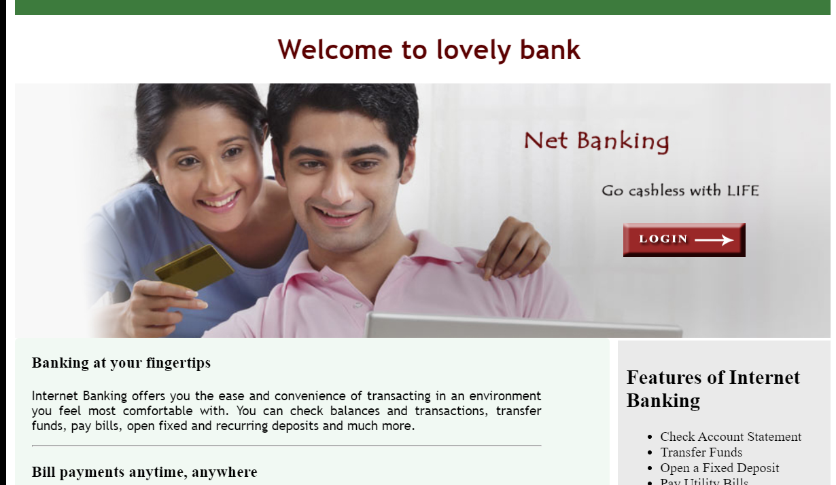

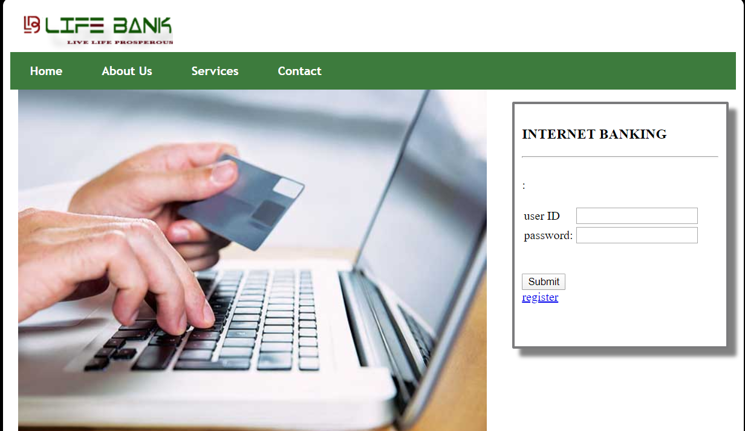

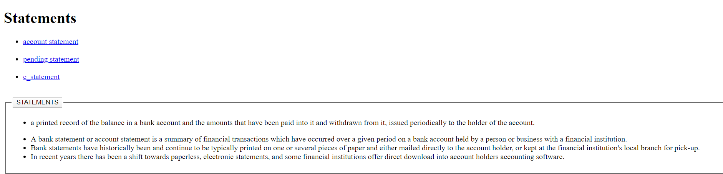

**SWOT Analysis**

**Strengths:**

* On demand and time saving access of services.
* Standardised working procedures
* Fast and Efficient.
* Funds from one account to the other gets transferred very fast.
* Users can manage multiple account from online banking system.

**Weakness:**

* Due to lack of awareness most users do not know the proper use online banking system.
* Users banking information may be spread out on several devices, making it more at risk.
* Users cannot have access to online banking, if users don’t have internet connections.
* Password security is must.
* Users might become annoyed by constant emails and updates.

**Opportunities:**

* To provide user friendly and convenient banking services.
* To provide value added services.
* The ability to have a larger customer base.
* The ability to take advantage of the growing opportunity of internet banking.

**Threats:**

* Continual changing of technology.
* Uncertainty of banking industry.
* Competition from the lower price operation.
* Possible failure of product due to non-acceptance of customers.